

Final Project Setup

Estimated time needed: **10** minutes

Objective for Exercise:

* For this project, you will use your IBM Watson Studio account from the previous chapter.

*If you have not created a Watson service before proceed with Step 1, otherwise go to Step 2:*

Step 1: For New Users (with no Watson service):

Go to the IBM Cloud Watson Studio page:

[Click here](https://cloud.ibm.com/catalog/services/watson-studio?cm_mmc=Email_Newsletter-_-Developer_Ed%2BTech-_-WW_WW-_-SkillsNetwork-Courses-IBMDeveloperSkillsNetwork-ML0101EN-SkillsNetwork-20718538&cm_mmca1=000026UJ&cm_mmca2=10006555&cm_mmca3=M12345678&cvosrc=email.Newsletter.M12345678&cvo_campaign=000026UJ)

You will see the screen in the figure below. Click the option in the red box.

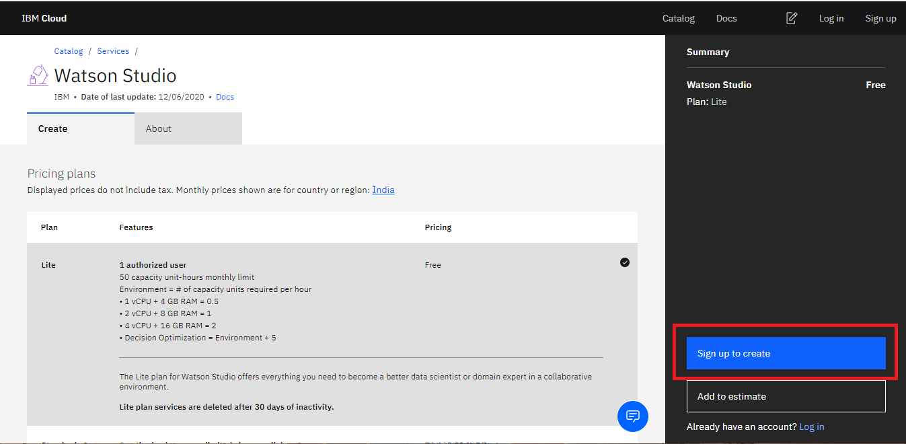

You will see the screen in the figure below. Enter **Email** and **Password** and the click **Next**.

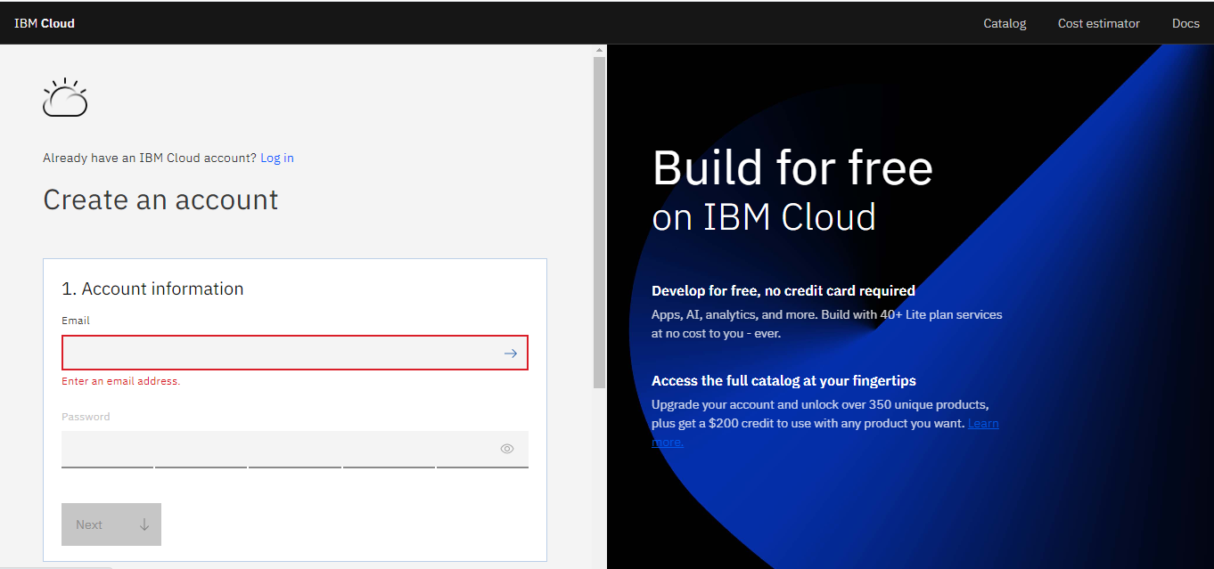

Enter the verification code to verify email and click **Next**.

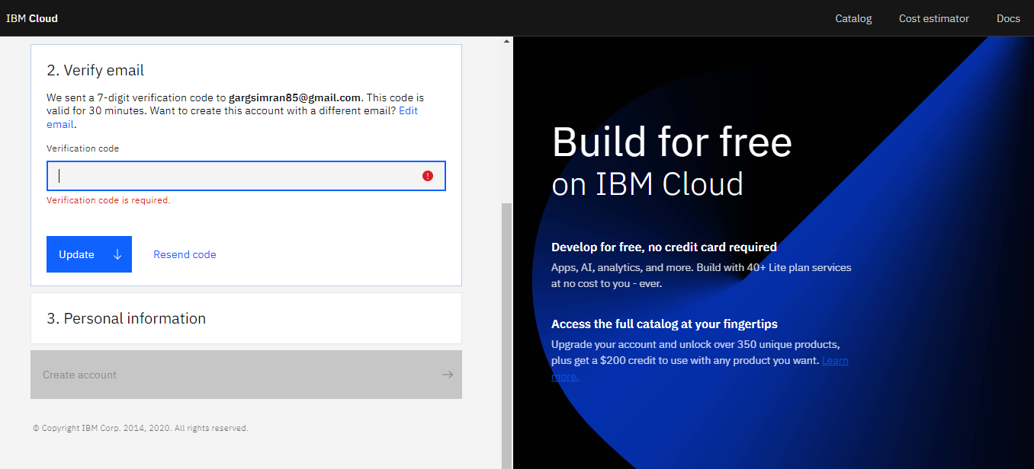

Enter your personal information and click **Next**.

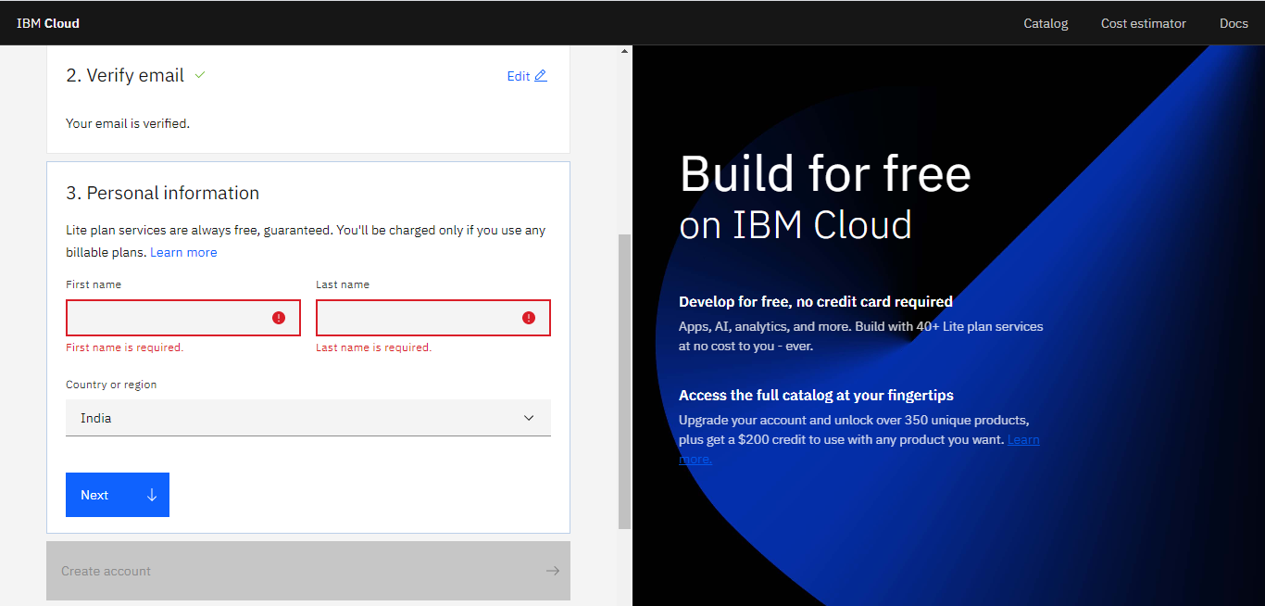

Accept the terms and conditions and click on **Create account**.

You will see the screen in the figure below. Click on the **Create** button.

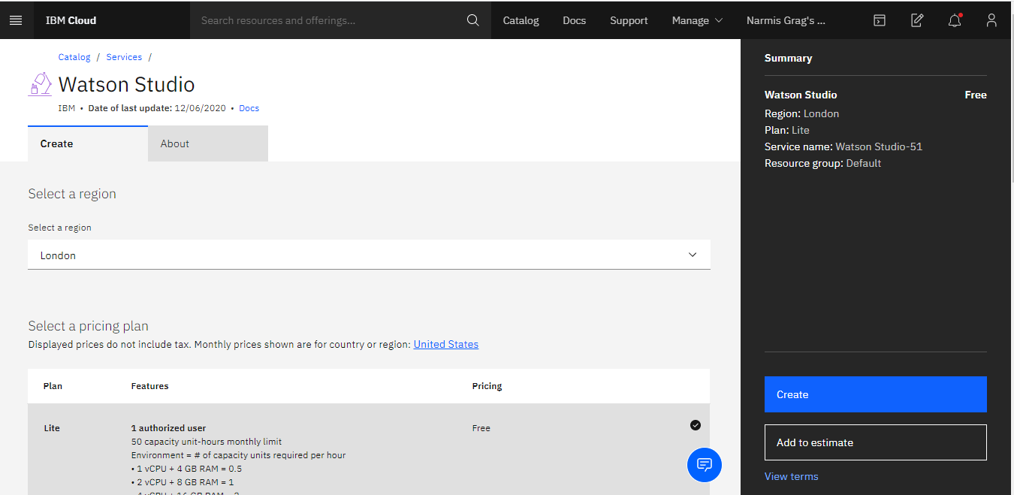

Now click **Get Started**.

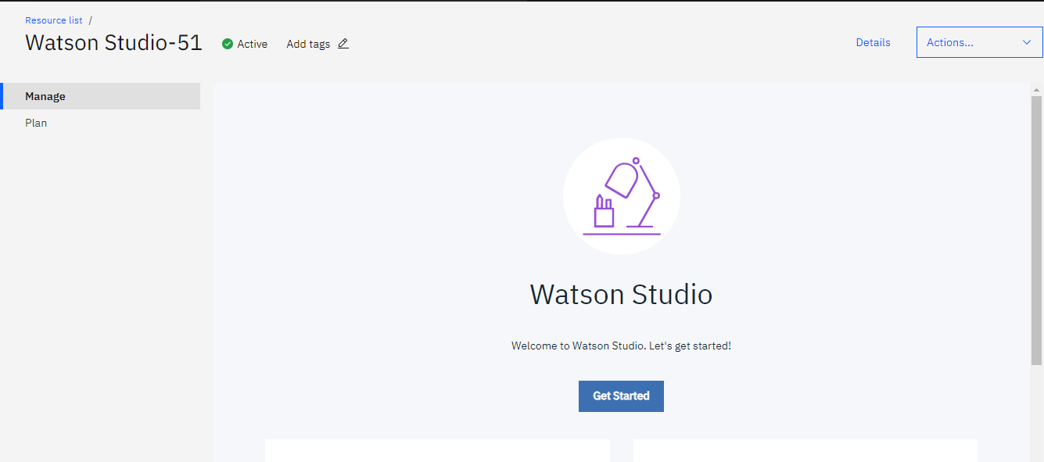

Then click **Go to IBM Watson Studio**.

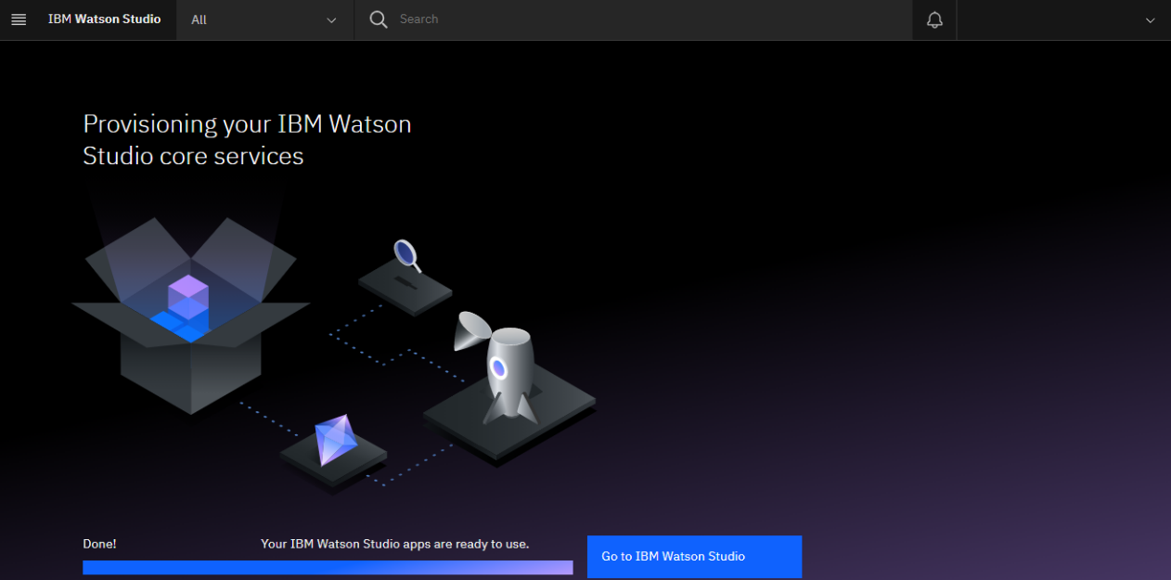

Then click **Continue**.

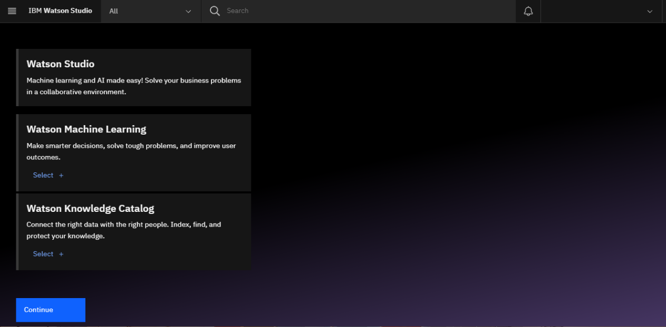

After creating the service continue with Step 2.

Step 2: For Existing Users (who already have Watson Service):

Go to the IBM Cloud Dashboard and click **Services**.

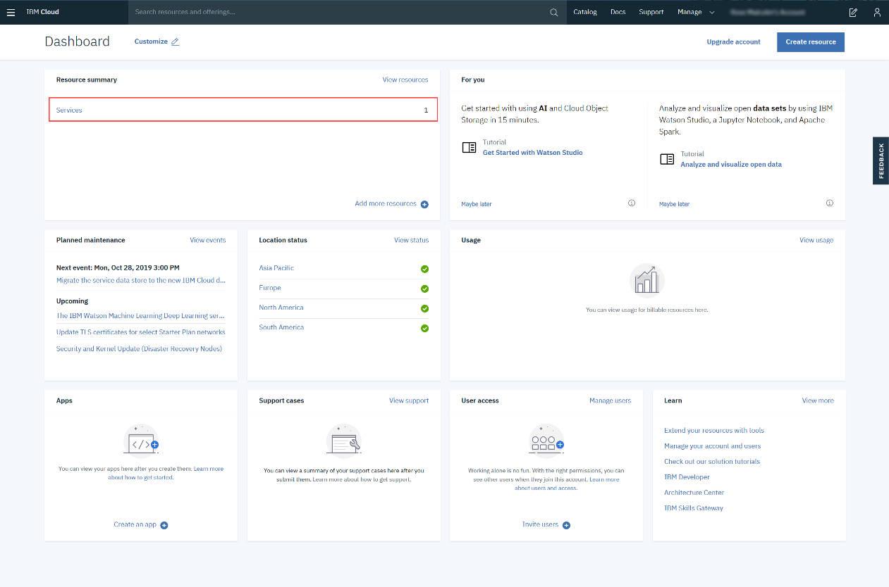

When you click on Services, all your existing services will be shown in the list. Click the **Watson Studio** service you created:

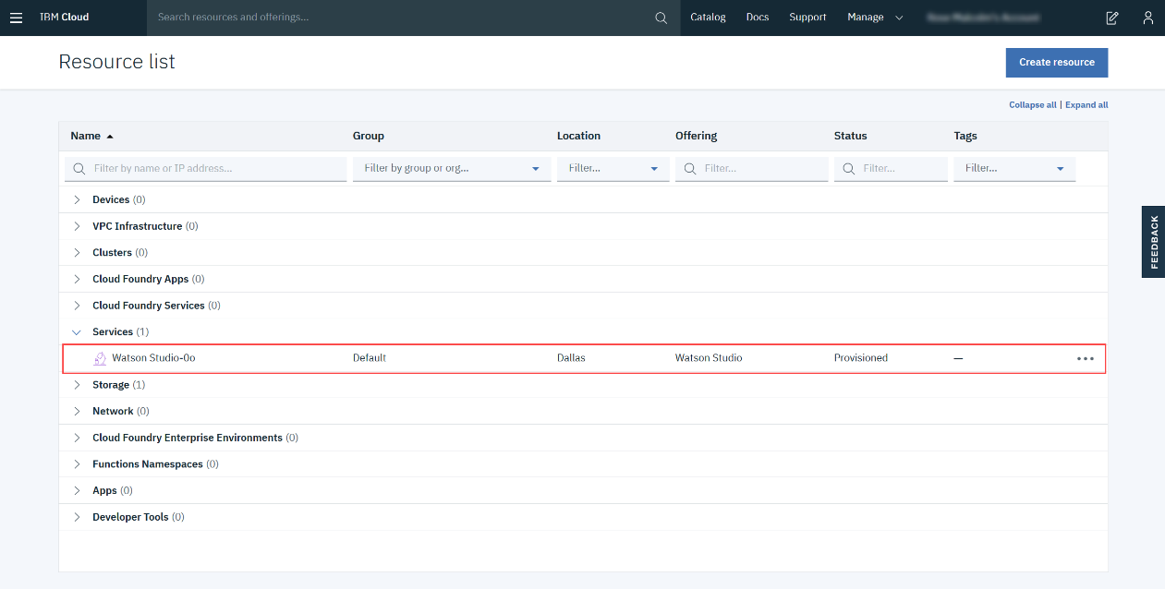

Then click **Get Started**.



Step 3: Creating a Project

Now you have to Create a project.

Click on **Create a project**.

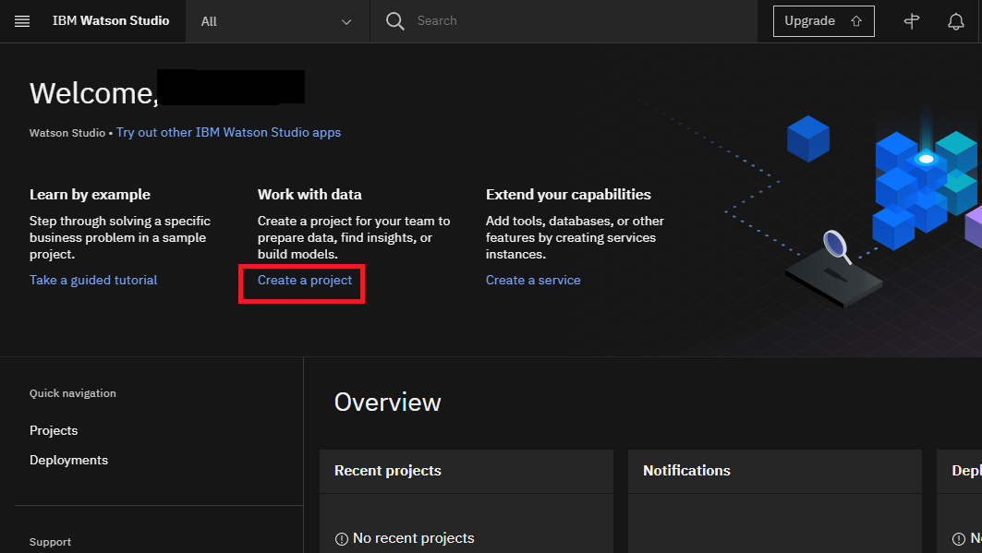

On the Create a project page, click **Create an empty project**.

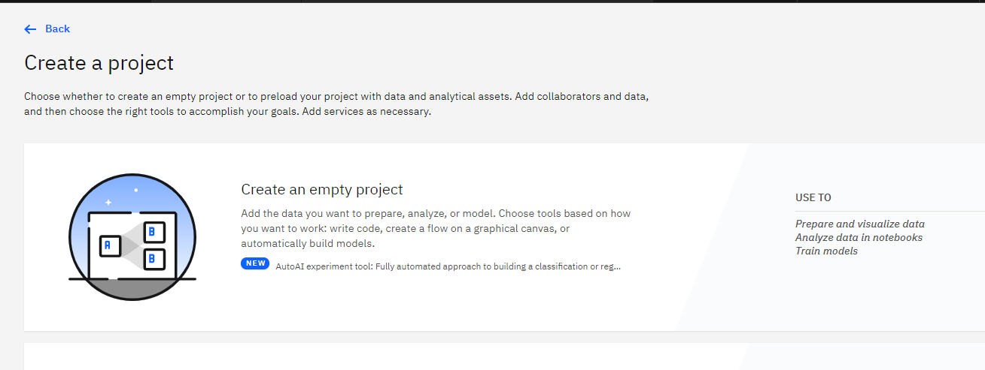

Provide a **Project Name** and **Description**.

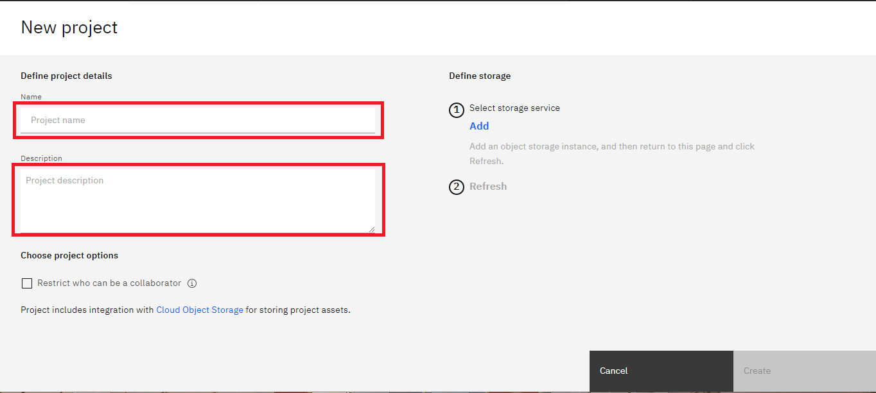

You must also create storage for the project.

Click **Add**

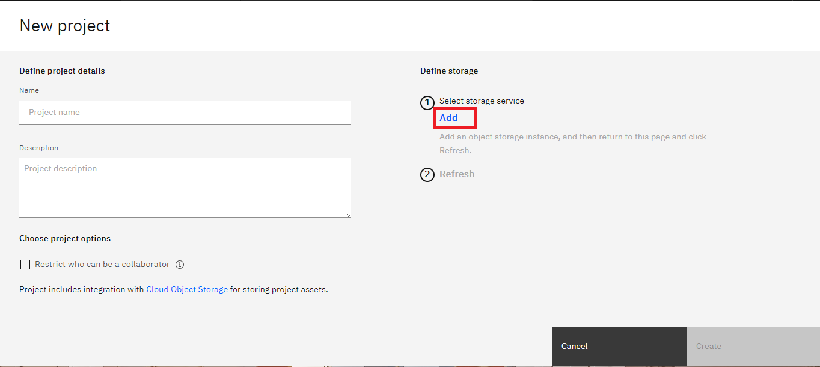

On the Cloud Object Storage page, click **Create**.

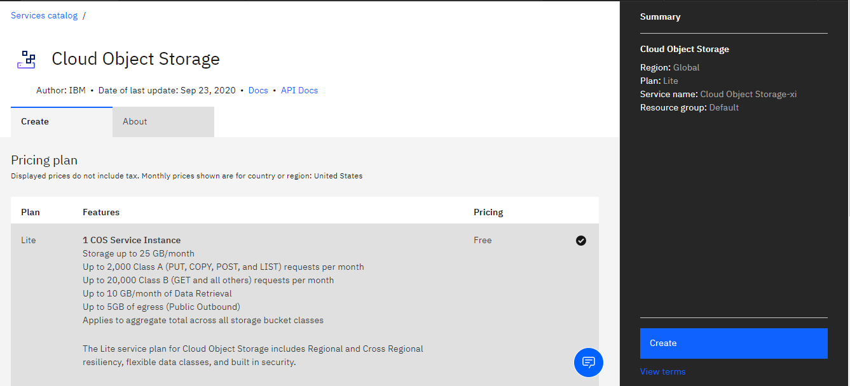

On the New project page, note that the storage has been added, click **Refresh** and then click **Create**.

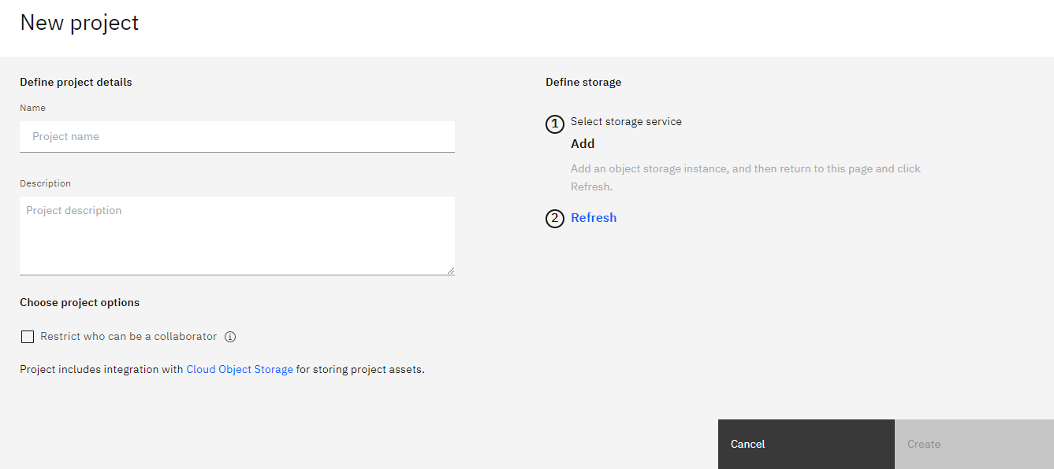

After creating the project continue with Step 4.

Step 4: Adding a Notebook to the Project:

You need to add a Notebook to your project. Click **Add to project**.

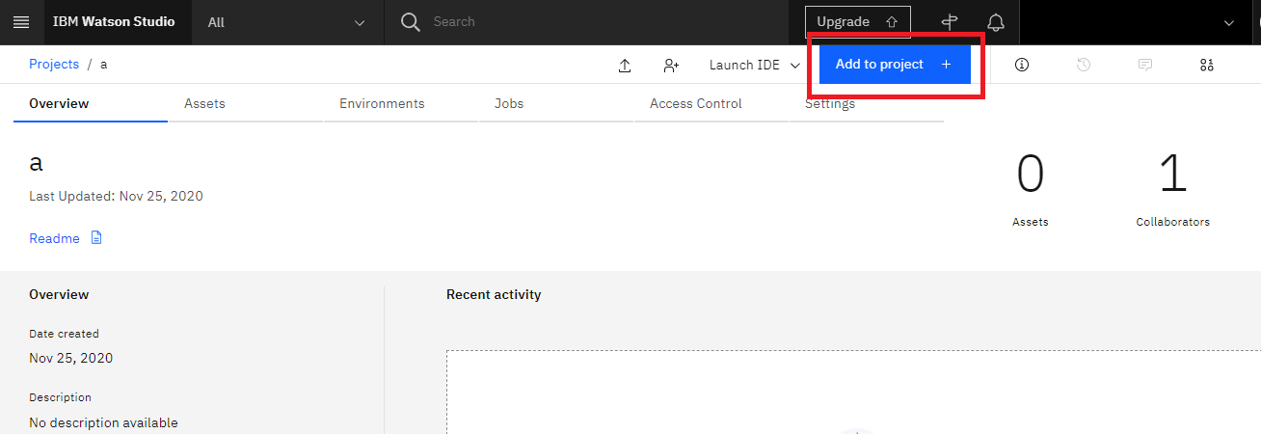

In the list of asset types, click **Notebook**.

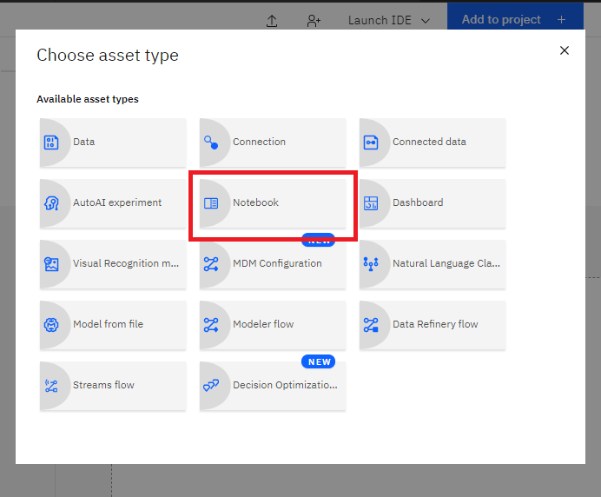

On the New Notebook page, enter a name for the notebook, and then click **From URL**.

Copy this [link](https://cf-courses-data.s3.us.cloud-object-storage.appdomain.cloud/IBMDeveloperSkillsNetwork-ML0101EN-SkillsNetwork/labs/Module%206/DS-8-Assignment.ipynb).

Paste it into the **Notebook URL** box, and then click **Create Notebook**.

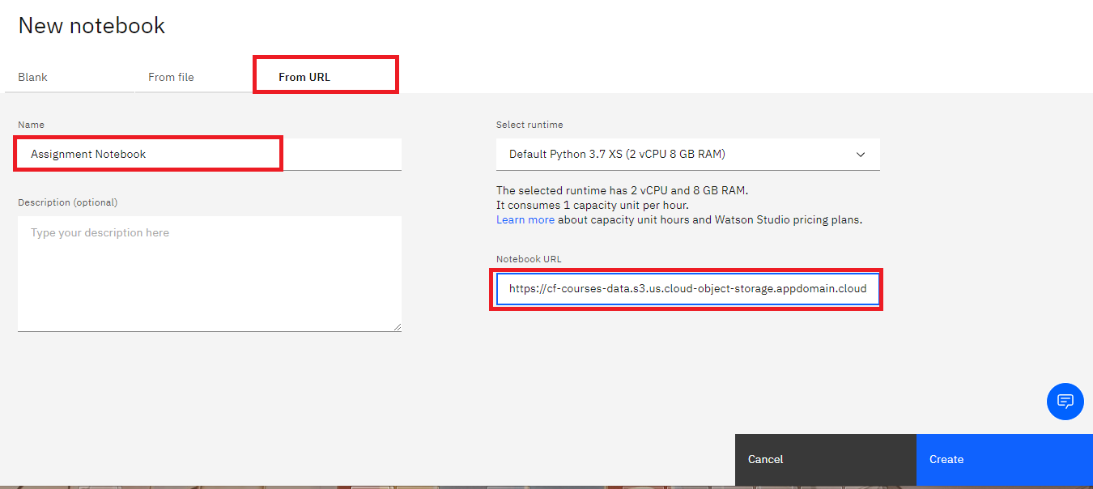

You will see this Notebook:

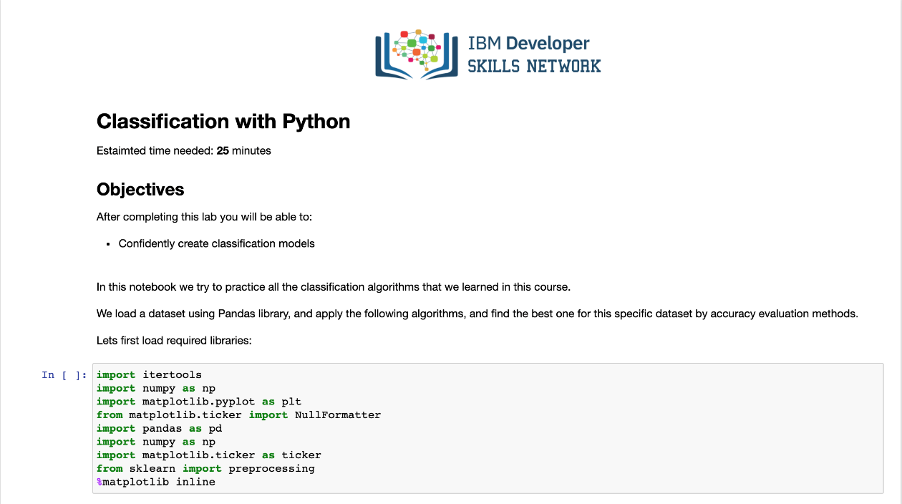

Once you complete your notebook you will have to share it to be marked. Select the icon on the top right a marked in red in the image below, a dialogue box should open, enable the option marked in red in the image below.

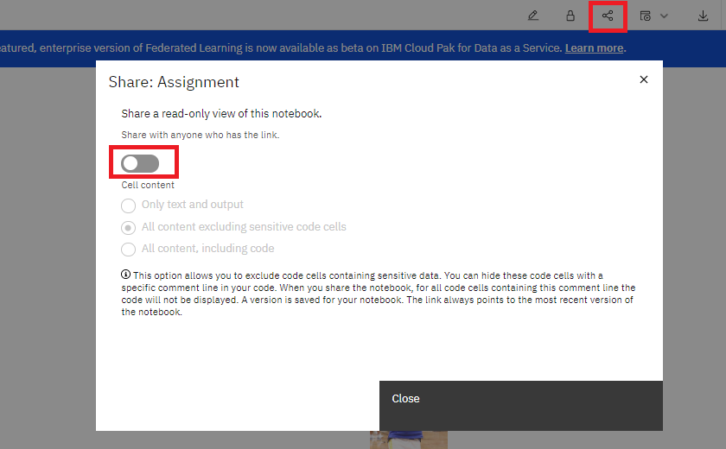

Once the option is enabled select the option all content excluding sensitive code cells and you can then share the notebook via a URL as shown in the following image:

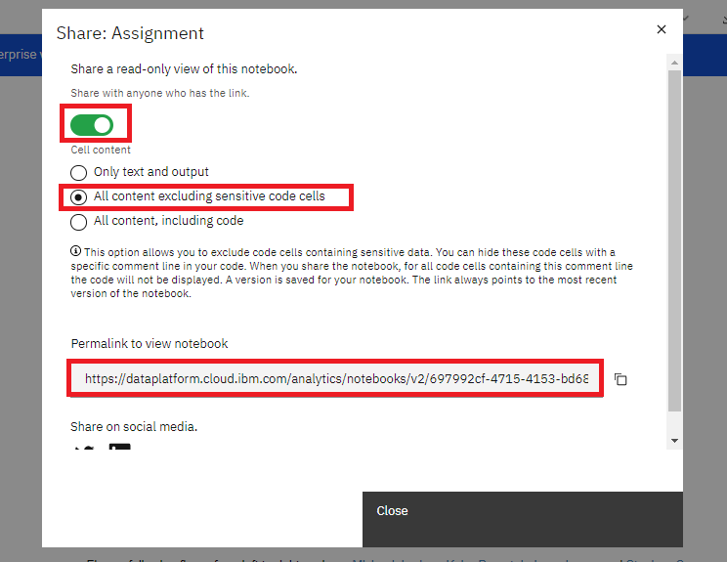

Author(s)

Joseph Santarcangelo

Changelog

| **Date** | **Version** | **Changed by** | **Change Description** |
| --- | --- | --- | --- |
| 2020-08-27 | 2.0 | Simran | Migrated the lab to course on GitLab |
|  |  |  |  |
|  |  |  |  |



## Objective(s)

At the end of this lab, you will be able to:

* Apply ML to a dataset to make inferences

## Instructions

Now that you have been equipped with the skills to use different Machine Learning algorithms, you will have the opportunity to practice and apply it on a data set.

In this scenario, you are a Data Scientist working for a college basketball team. Your coaches have asked you to look at historical data to see which team metrics (individually or in combination) make a team more likely to make it into the Final Four. For example, if a team is more efficient defensively, does this have a direct relationship to their ability to get into the Final Four? What about defensively efficiency along with overall wins? Your job is to figure out if there is a combination of metrics that give a team more of a chance of making it into this tournament.

Something to keep in mind is that when trying to predict results of basketball tournaments there are many variables that need to be taken into account. As a result of this creating accurate models is incredibly hard. In the sports betting industry an accuracy rate of anything over 55% is considered good as it indicates profits.

You will load a historical data set from previous seasons, clean the data, and apply different classification algorithms to the data. You are expected to use the following algorithms to build your models:

* k-Nearest Neighbour
* Decision Tree
* Support Vector Machine
* Logistic Regression

The results are reported as the accuracy of each classifier, using the following metrics when applicable:

* Jaccard index
* F1-score
* Accuracy

## Review Criteria

**This final project will be graded by your peers who are also completing the course during the same session. This project is worth 25 marks of your total grade, and is distributed as follows:**

1. Build a KNN model using a value of k equals five, find the accuracy on the validation data **(1 mark )**
2. Determine the accuracy for the first 15 values of k the on the validation data:. **(1 mark )**
3. Determine the minimum value for the parameter that improves results on validation data. **(1 marks)**
4. Building model using Support Vector Machine. **(2 marks)**
5. Train a logistic regression model and determine the accuracy of the validation data (set C=0.01) **(2 marks)**
6. Calculate the F1 score and Jaccard Similarity score for each model from above. Use the Hyperparameter that performed best on the validation data **(2 marks)**

### **Step-By-Step Assignment Instructions:**

**Step A:** Create an account in Watson Studio if you don't have an account already. (If you already have an account, jump to Step B).

1. [Final Project Setup](https://cf-courses-data.s3.us.cloud-object-storage.appdomain.cloud/IBMDeveloperSkillsNetwork-ML0101EN-SkillsNetwork/labs/Module%206/Final%20Project%20Setup.md.html)

**Step B:** Sign into Watson Studio and import your notebook

1. Sign in to [IBM Cloud Watson Studio](https://www.ibm.com/cloud/watson-studio)
2. Click on "Create a project".
3. On the Create a project page, click "Create an empty project".
4. Give a name to your project and a description for your reference, then set-up your project as follows, then click "Create".

**Notice 1:** Because you are going to share this project with your peers for evaluation, please make sure you uncheck "Restrict who can be a collaborator".

**Notice 2:** You must create an IBM Object Storage, if you don't have an IBM Object Storage, you can use the free Lite plan.

1. From the top-right, click on "Add to project" and then select "Notebook".
2. In the "New Notebook" form, click on "From URL" and right-click on [Notebook URL](https://cf-courses-data.s3.us.cloud-object-storage.appdomain.cloud/IBMDeveloperSkillsNetwork-ML0101EN-SkillsNetwork/labs/Module%206/DS-8-Assignment.ipynb), copy link and paste it.
3. Give your notebook a proper name and description and click on "Create Notebook" to initialize the notebook.

**Step C:** Complete the Notebook

1. Start running the notebook.
2. Complete the notebook based on the description in the notebook.

**Step D:** Share the Notebook

1. Click on the share icon on the top-right side of your page.
2. Activate the "Share with anyone who has the link".
3. Select "All content excluding sensitive code cells".
4. Copy the link from "Permalink to view notebook".

### **Submit your Notebook for Grading**

Paste the shared link of your Notebook in the provided text box below for peer-review.